Wireshark Network Traffic Analysis

Mini Project

Objective
To capture and analyze real network traffic using Wireshark and identify DNS queries, HTTP requests, TCP communication, and TLS handshake.
Tool Used
- Wireshark

Environment
- Interface: Wi-Fi
- Local IP: 192.168.1.2
- Gateway: 192.168.1.1

Traffic Analysis
DNS Analysis
Filter Used: dns
Observed Traffic:
- Source: 192.168.1.2
- Destination: 192.168.1.1
- Protocol: DNS
Domains Observed (from capture):
- c.pki.goog
- mobile.events.data.microsoft.com
- sharepoint.com
Details:
- Standard query A and AAAA requests observed
- DNS responses received from local gateway
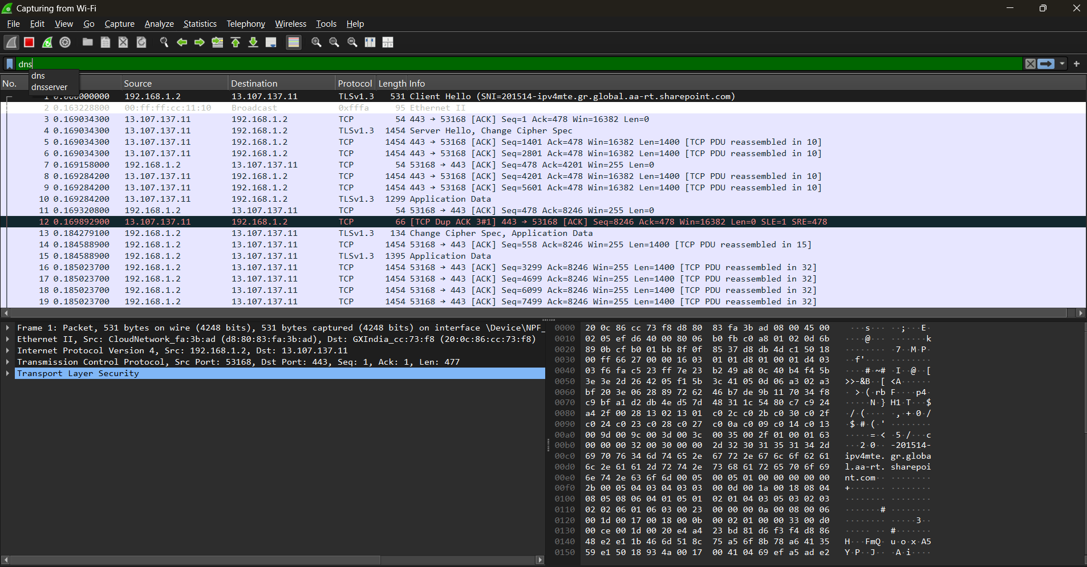
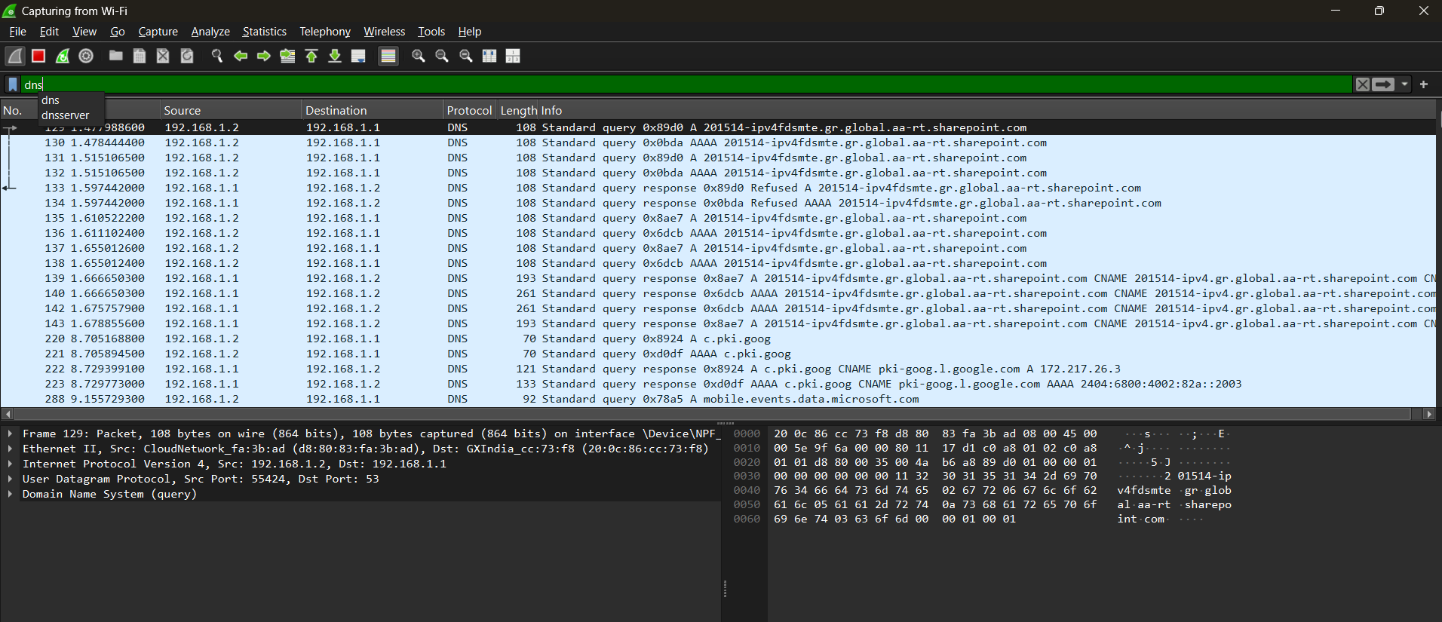

HTTP Analysis
Filter Used: http
Observed Request:
GET /r/r4.crl HTTP/1.1
Details:
- Source IP: 192.168.1.2
- Destination IP: 172.217.26.3
- Protocol: HTTP
Important Headers (captured):
- Host: c.pki.goog
- User-Agent: Microsoft-CryptoAPI/10.0
- Connection: Keep-Alive
Response:
HTTP/1.1 304 Not Modified
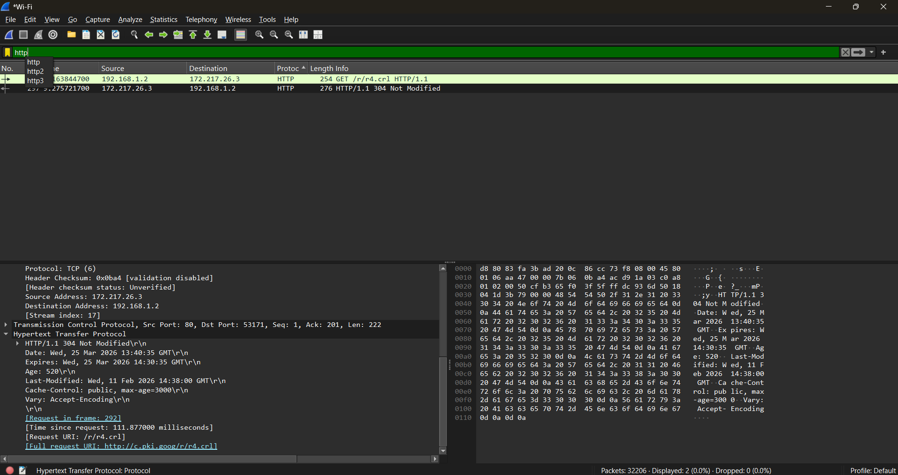
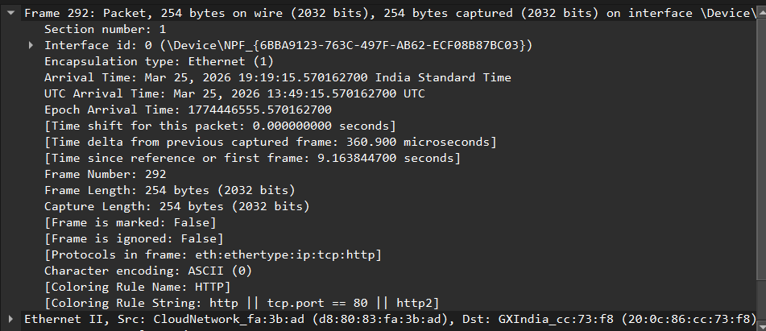

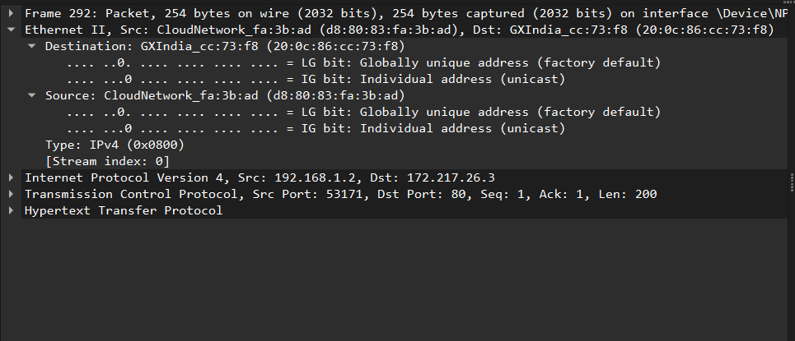
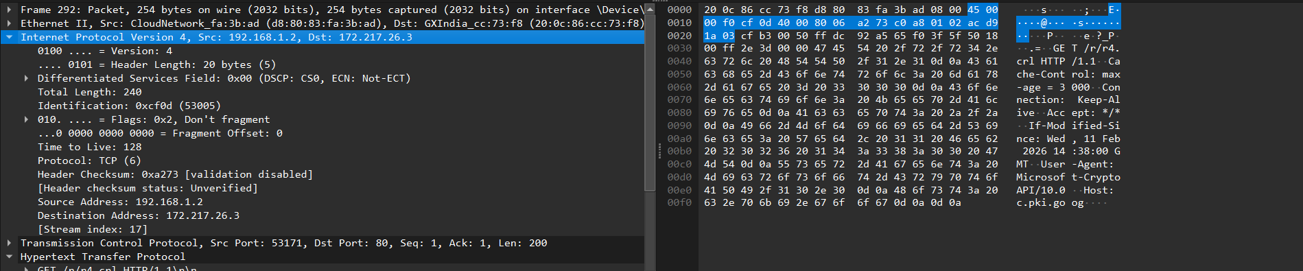
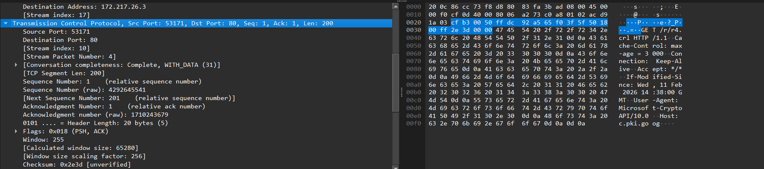

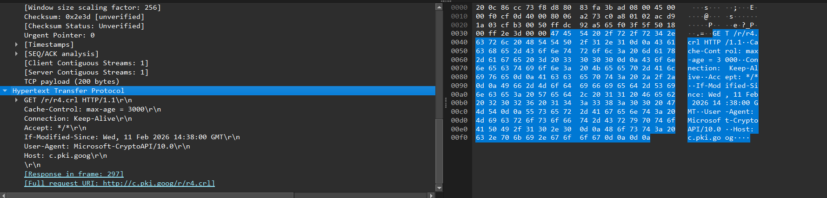
TCP Analysis
Filter Used: tcp
Observed Communication:
- Source: 192.168.1.2
- Destination: 13.107.137.11
- Destination Port: 443
Details:
- Multiple ACK packets observed
- TCP segments reassembled
- Stable communication established

TLS Handshake Analysis
Observed:
- Protocol: TLSv1.3 / TLSv1.2
- Handshake Type: Client Hello
Captured Details:
- Version: TLS 1.2 (0x0303)
- Cipher Suites present
- Extensions observed
Server Name (SNI):
201514-ipv4mte.gr.global.aa-rt.sharepoint.com

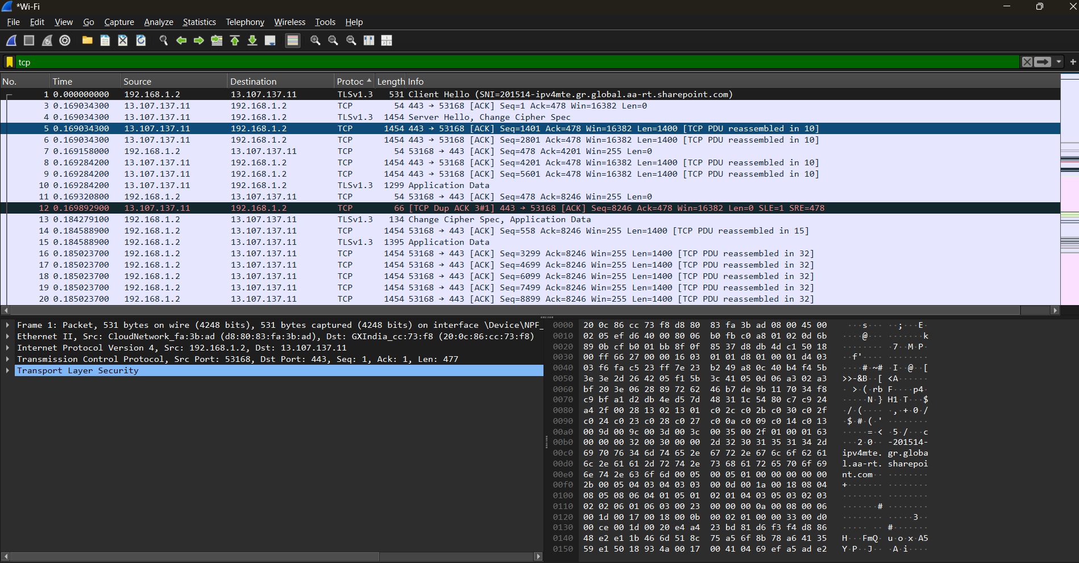
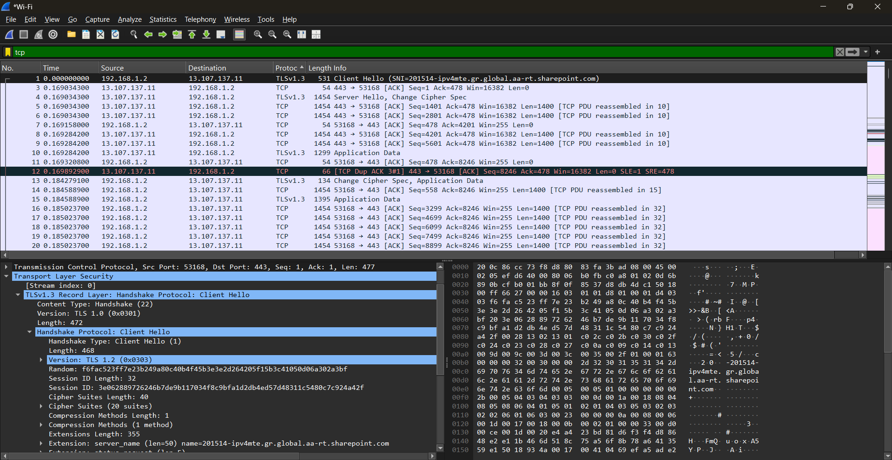
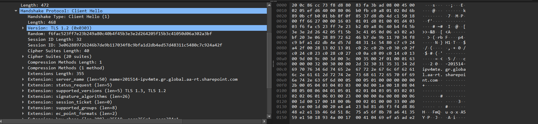

Key Learnings
- Real DNS query and response analysis
- HTTP request inspection
- TCP packet behavior understanding
- TLS handshake observation
- Practical use of Wireshark filters

Conclusion
The analysis demonstrates real-world network traffic inspection using Wireshark. The captured packets show normal communication between a client system and external servers including DNS resolution, HTTP request, and encrypted TLS communication.

